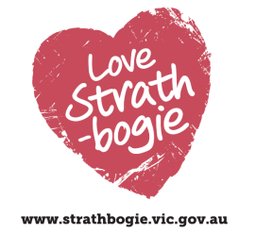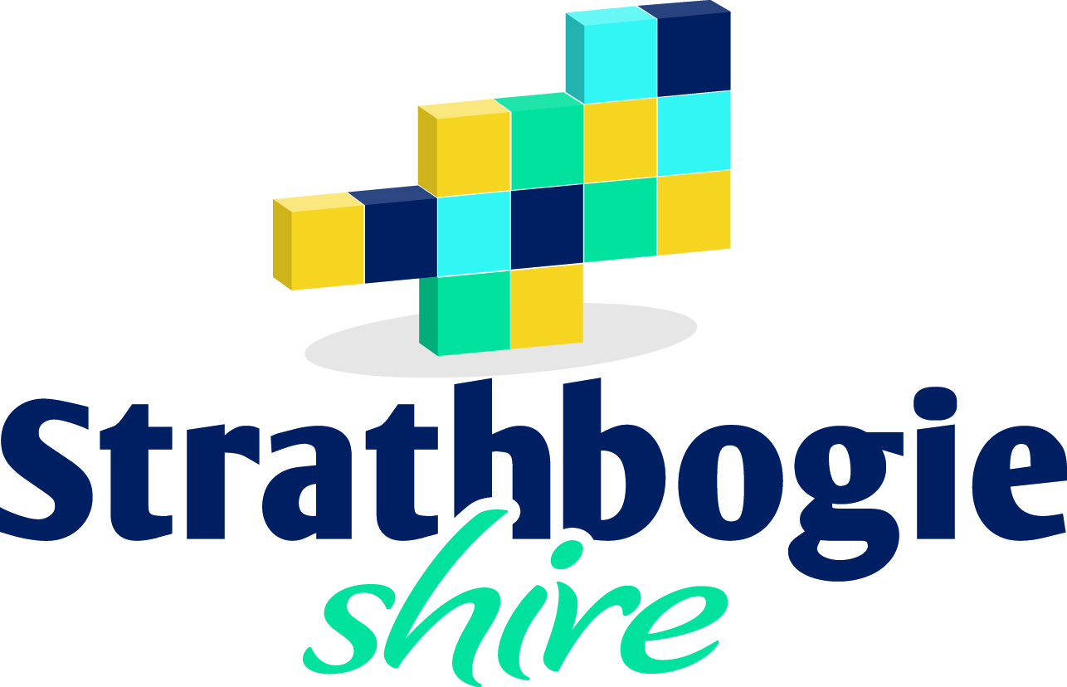

**Youth Services**

Our Youth Department offers a wide range of programs and training for young people aged between 12 and 25 years. Opportunities for young people to build their knowledge, skills and understanding in event planning and management are provided with the help of funding provided by the State Government’s FReeZa Program and Council.

**EVOLVE Youth Committee**

A committee of young people that meet to discuss, plan and manage a number of events catering to the diverse needs and interests of youth in our community.

The events are focused of the areas of Music, Arts and Culture.

The EVOLVE youth committee meet on a weekly basis, from 4:30pm each Monday at the Evolve Space in Bury St, Euroa.

If you are aged between 12 and 25 and live, work or study in the Strathbogie Shire you may like to become a member of the committee and make a difference in the community.

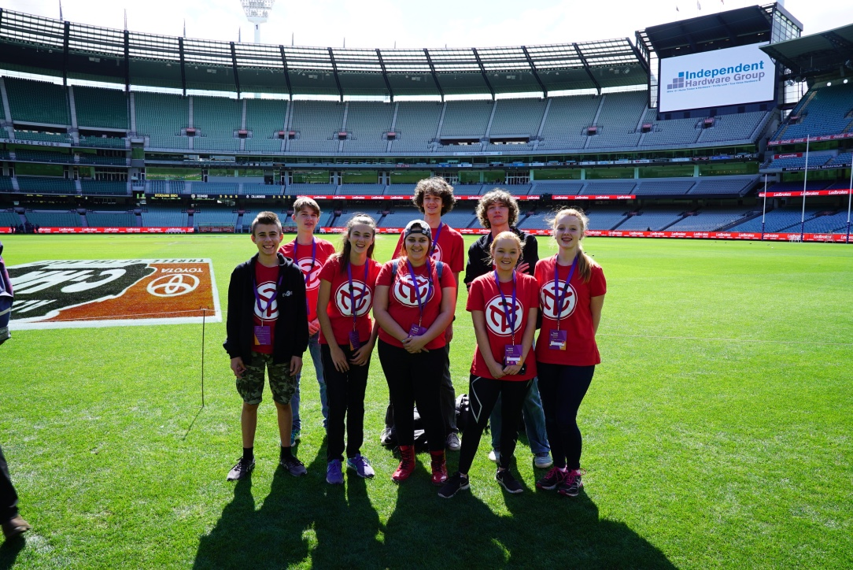

**Events**

Events held by the Youth Services Department in the past 12 months include:

* **MusoMagic**  
  *Innovative, outstanding workshops and programs that unite, engage, motivate and empower groups of all ages and backgrounds through the magic a song*Find out more at www.musomagic.com
* **Fast Track Talent Show – Strathbogie***An incredible performance experience for performers of all ages, genres and levels of skill*Find out more at www.fasttracksinging.com.au
* **Youth Movie Nights at the Euroa Community Cinema**

*An opportunity for youth of the shire to enjoy a night out watching a movie on the big screen*

* **Youth Politics Camp**

*An opportunity to be involved in an innovative two day camp that will focus on understanding the Australian political system. The camp is an opportunity to meet other interested young people to discuss issues you care about*

* **NOW (Nagambie on Water) Festival**

*An annual festival that celebrates the wonderful environment surrounding the Nagambie Township. EVOLVE was responsible for music and MC elements of the main stage*

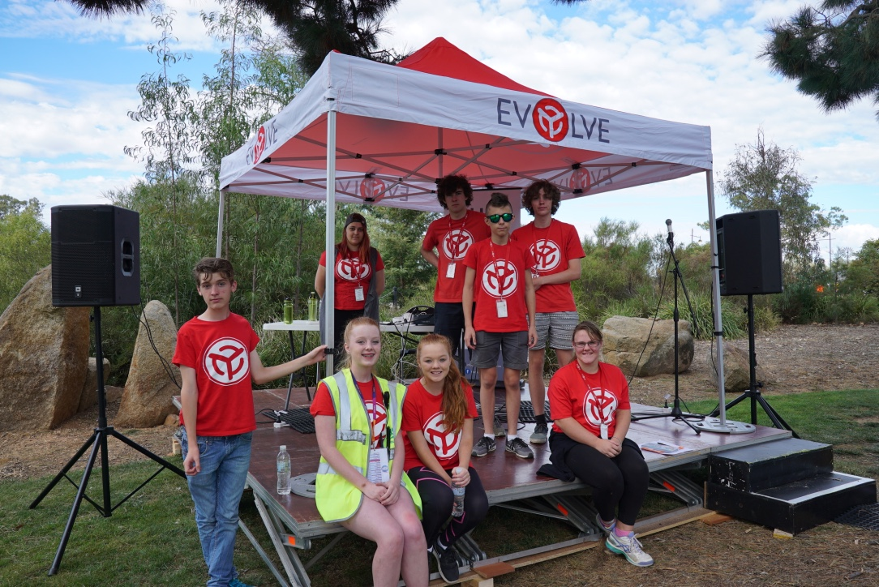

**To contact the Youth Department**

(03) 5795 0000   
or freecall 1800 065 993



 info@strathbogie.vic.au   
with Attention: Youth Department as your subject

EVOLVE Youth of Strathbogie



@evolveyouthofstrathbogie



evolveyouth

\\\